Graham Road & Clarence Park GP Surgeries

Case for Change

Version Control
Version Number | Author | Date | Review
V0.1 | Linda Buczek | 24/12/2018 | First draft
V0.2 | Mark Graham | 07/01/2019 | Initial review
V0.3 | Fraser Black | 08/01/2019 | Financial appendices
V0.4.2 | Linda Buczek | 22/01/2019 | Penultimate draft for review by:  - For All Healthy Living Company CIC Ltd  - Practice Patient Participation Group sub-group  - Mary Adams, BNSSG Partnerships & Engagement Manager  - Colin Bradbury, BNSSG Area Director  - David Moss, BNSSG Head of Primary Care Contracts  - Mel Green, BNSSG CCG Head of Locality Development  - Angela Metcalf, NHS England Patient Experience lead  - Jenny Collins, NHS England South Region South West Contracts Manager  - Denys Rayner, BNSSG CCG ISS Project Manager  - Roz Willis, North Somerset Council Health Overview Scrutiny Panel (HOSP) Chair  - Richard Nightingale, North Somerset Council Local Ward Councillor  - Mike Bell, North Somerset Council Local Ward Councillor
V0.5 | Mark Graham | 29/01/2019 | Final draft for review
V1.0 | Linda Buczek | 30/01/2019 | Final version

Distributed To
Version | Name | Area of interest
V1.0 | Locality Board, Weston, Worle & Villages | For discussion and consideration
V1.0 | BNSSG CCG Primary Care Commissioning Committee (PCCC) | For discussion and consideration
V1.0 | Health Overview Scrutiny Panel (HOSP) | For discussion and consideration

Supporting Documents
Author | Document |  | Reason for Inclusion
Mary Adams  BNSSG CCG |  | Patient & Public Involvement and Communications Plan – Clarence Park and Graham Road Proposal | Iterative document which forms part of the Case for Change submission
Niema Burns  BNSSG CCG |  | Equality Impact Assessment  (current version dated 30/01/2019) | Iterative document which forms Part of the Case for Change submission.
Fraser Black  Locality Health Centre CIC |  | Financial options appraisal  (analysis section only; data to follow when agreed with BNSSG CCG) | Financial position for context

Case for Change
Executive Summary
Locality Health Centre CIC Ltd is a not for profit organisation which provides primary care medical services for people in Weston-super-Mare. In the summer of 2018 Locality Health Centre Community Interest Company (LHC CIC) took the decision not to tender for the Provider of Medical Services (PMS) contract offered for Locality Health Centre. This led to a clinical and associated sustainability review of their other two practices – Graham Road Surgery and Clarence Park Surgery.

The viability of a GP practice with less than 5000 patients is widely questioned, and in line with the national GP Forward View and the local Sustainability and Transformation Partnership (STP) Healthy Weston initiatives, practices are required to be more efficient and resilient. Given the limitations of the Clarence Park Surgery estate, and the associated scalability of Graham Road Surgery, it is proposed to consult with the local public and stakeholders about the options which will sustain a combined patient list of approximately 14,000 patients.

There are a number of interlinked factors for consideration of available options. Of primary importance is the need to ensure the best clinical skill mix available for the whole patient population within the resources available. Meetings with the Patient Participation Group (PPG) and a public meeting in November 2018 have informed the options appraisal.

Following consideration and discussion of a number of options, it was agreed that a merge of lists and consolidation of services will enable clinicians to offer a better range and continuity of care whilst providing a more resilient platform for the future of health services in Weston-super-Mare. This is set in the context of a review of primary care estate for Central Weston which may lead to the provision of new premises for the local population. Associated service delivery for these sites would then be seen as part of this phased development of primary care provision for central Weston-super-Mare.

This paper recommends 2 options for further consultation (from the 4 considered – see Options: page 4):

• Option 3
Merge the two practices/ patient lists and operate Clarence Park as a branch site
This can enable Graham Road to offer acute and routine GP services for the merged patient list with the associated allocation of Advanced Nurse Practitioner (ANP) and Doctors. Clarence Park will act as a branch site, offering Advanced Nurse Practitioners, Treatment Room and Chronic Disease services led by nurses, to the merged patient list.

• Option 4
Merge the two practices/ patient lists, close the Clarence Park site and operate all services from Graham Road
This option offers the most financially sustainable and efficient use of clinical resource and premises and has already been offered to the public domain for consideration.

We believe these proposals best meet the needs of the local patient population for a short, medium and long term perspective, whilst also enabling the practice business to be sustainable during this time of change across the locality.

Practice Information
Criteria | Graham Road Surgery | Clarence Park Surgery
Address | 22 Graham Road  Weston-super-Mare  Somerset  BS23 1YA | 13 Clarence Road East  Weston-super-Mare  Somerset  BS23 4BP
Telephone | 01934 628 111 | 01934 415 080
Web address | www.grahamroadsurgery.nhs.uk | www.clarenceparksurgery.nhs.uk
List size | 8668 | 4667
Practice boundary | Central Ward, Weston-super-Mare
NHS Choices rating | 1.5 stars (out of 5) | 1.5 stars (out of 5)
Opening Hours | Mon – Fri 08.00am - 6.30pm and  Improved access:  Tue & Fri from 6.30pm – 8pm  Sat 9.00 – 12.00 (GP, ANP & HCA) | Mon to Fri 08.00am to 6.30pm
Clinical space | 11 consulting rooms  3 treatment rooms | 2 consulting rooms  3 treatment rooms

Background to Proposal
Reasons for proposing this change
Locality Health Centre CIC Ltd is a not for profit organisation which provides primary medical services for people in Weston-super-Mare. Unlike most GP practices it is not owned by GP partners but has a Board of Directors who take no dividends. The business is led by a management team including GP and Nurse clinicians. Provenance has developed from running the Locality Health Centre practice on the Bournville estate, with a strong commitment to tackling health inequalities and providing a high level of service to disadvantaged groups.

Clarence Park Surgery is based in an old semi-detached building close to the sea front and 0.8 of a mile from Graham Road Surgery. The practice serves a population of just under 5000 patients, with a high proportion of elderly people. In 2016 the existing 2 GP Partners wished to reduce their involvement and to move away from the area respectively. Together with other planned retirements the practice became unstable and was struggling to attract replacement GP’s. Discussions with the remaining partner led to Locality Health Centre CIC Ltd taking over the practice from October 2016.

Graham Road Surgery has existed in Weston-super-Mare for many years and has operated from the current premises for 25 years. During this time the building has undergone two significant alterations to improve facilities for the extensive health care provided. The practice has more than 8500 patients and the boundary covers the Central Ward of Weston-super-Mare. From 2010 the practice was struggling to retain and recruit GP’s. The two partners made a number of unsuccessful attempts to sell the business and in April 2017 the Locality Health Centre CIC Ltd, with support from NHS England, took over the practice. They have successfully returned it to a teaching practice, and aim to stabilise the business and for it to work more closely with their other two practices – Locality Health Centre and Clarence Park Surgery.

Accordingly, from 2017, the three practices have shared clinical and non-clinical staff and introduced coordinated and consistent ways of working whilst respecting the respective patient requirements.
In the summer of 2018 the Locality Health Centre CIC took the decision not to tender for the new PMS contract offered at the Locality Health Centre. This led to a review of its other two existing practices and toward creating a sustainable future for them. It became clear that a merge of lists, enabling clinicians to manage patients from either site would enable greater resilience in the team and to support the varying demands on the services on a day to day basis. The merging of lists would also lead to better support for either service in the event of significant disruption such as power or telephony failure.

However this would not overcome the longer term challenge of the duplication of clinical and non-clinical roles across the two sites. The viability of a less than 5000 patient practice is being questioned across the whole of Primary Care and in line with national and local initiatives the practices are being challenged to be more efficient.
Options
There are a number of interlinked factors for consideration of available options. Of primary importance is the need to ensure the best clinical skill mix available for the whole patient cohort within the resources available. Consideration was also given to the state of premises at Clarence Park and the ability to create more clinical space at Graham Road. Meetings with patients and the public have informed the options appraisal.

The developing model of Primary Care across the country means that Clarence Park is now regarded as a small surgery and has one of the lowest numbers of patients in BNSSG CCG geographical area. Financial allocation for a practice is worked out on the number of patients they have which therefore impacts on their ability to afford the best clinical skill mix required to meet the diverse needs of the patients. It follows that combining the patient lists to create a sustainable income base, enables patient service delivery based on maximised clinical resource and deployment.

Following separate discussions with Dr Nick Cooper (Practice Clinical Lead) and Ruth Rice ANP (Practice Lead Nurse), Fraser Black (Finance Director, LHC CIC), Mark Graham (Chief Exec, LHC CIC), Colin Bradbury (Area Director, CCG), Patient Participation Group consultation sub-group and Linda Buczek (One Care BNSSG Ltd) the following options were identified and considered:
- Option 1
Do nothing
This option has been discounted as Clarence Park is not able to provide the financial platform required to offer a sustainable service to patients.
- Option 2
Merge the two practices/ patient lists and continue to deliver full clinical services at both sites
This option has been discounted as the combined financial platform cannot provide the number of doctors required to offer a sustainable full clinical service provision across both sites.
- Option 3
Merge the two practices/ patient lists and operate Clarence Park as a branch site
This can enable Graham Road to offer acute and routine GP services for the merged patient list with the associated allocation of ANP and Doctors. Clarence Park will act as a branch site, offering Advanced Nurse Practitioners, Treatment Room and Chronic Disease services led by nurses, to the merged patient list.
- Option 4
Merge the two practices/ patient lists, close the Clarence Park site and operate all services from Graham Road
This option offers the most financially sustainable and efficient use of clinical resource and premises and has already been offered to the public domain for consideration

Having discussed these outline options the clinical and management leadership team of the practices recommend that consultation takes place on Options 3 and 4.

Positioning & Benefits
Clinical
Whilst the need for review was initially sustainability driven, it has always been the clear and primary intent is to offer the best clinical service to patients. There is national evidence to indicate that maximising continuity of care has the greatest effect on patient outcomes. For practices to achieve this they have to utilise their clinical resources in the most appropriate way for their specific patient population. The proposed options together with the establishment of the acute care micro-team will facilitate care being provided to patients by the right person, in the right place and at the right time
The patient populations across Clarence Park and Graham Road are broadly the same. To maximise clinical service delivery for all patients it is clear the team must consider innovative ways of working. Consolidating resource to offer a doctor-led acute service and a corresponding nurse-led treatment room service provides a good solution. Whilst this is more sustainable on one site, offering a branch, nurse-led offer at Clarence Park can be considered.
Consolidating Doctor and Advanced Nurse Practitioner resource at Graham Road enables a micro-team to be established, focusing on patients who need to be seen ‘on the day’. This consolidation will enable the practice to increase access and availability of appointments. It also enables other clinicians such as Prescribing Pharmacists and other allied health professionals, to offer greater continuity of care to patients with on-going and multiple, complex health conditions. These options will reduce the potentially inefficient duplication of work, thereby freeing up clinician time in order to provide improved continuity of care and focus on further improvements to the quality of care being provided.
Correspondingly the nurse-led service can provide increased access and availability of treatment room and long-term condition appointments to support patients with their wound management, routine treatment room requirements and chronic disease management. This will include the complex care of patients with heart disease, respiratory disease, diabetes and kidney disease.

Consolidating clinical resource will enable greater practice resilience and the opportunity for better cover and support to maximise patient appointments and clinical cover. As well as being in the interests of patients, these changes will also benefit clinicians as this will make the organisation a more attractive place to work and thereby improve recruitment and retention.

Patient
As has already been shown, options 1 and 2 are not financially viable and the outcome would be that the Clarence Park contract may have to be returned. This is clearly not in the best interests of patients.

Options 3 and 4 however improve access to both doctor and nurse led services and sustain the future of the practice. The proposals align to the new ‘digital front door’ initiative which is being introduced across practices in Weston and Worle. This wholesale system change will bring clinicians closer to the initial ‘triage’ of patients, supporting greater self-care, online consultations where appropriate, and greater patient choice in the clinician they wish to see.

Graham Road already offer Improved Access appointments and Options 3 would enable this to be expanded further to Clarence Park, offering more nurse appointments outside of the core hours of 08.00am to 6.30pm Monday to Friday.

The consolidation of resource and services allows the practice to better utilise vital clinical space at both sites, and enables those with more complex, frequent care requirements to be seen at Clarence Park where there is less pressure on parking.

Patient Population and Demographics
Graham Road Surgery and Clarence Park Surgery are within 0.8 miles from each other in central Weston-super-Mare and have broadly consistent patient demographics. Both have the same North Somerset INSIGHT profile, namely: 69% of the population are classed as ‘struggling’, 30% are classed as ‘deprived’ and 1% classed as ‘comfortable. The information below shows a similarly aligned spread of population age/ circumstance and ethnicity across each practice.
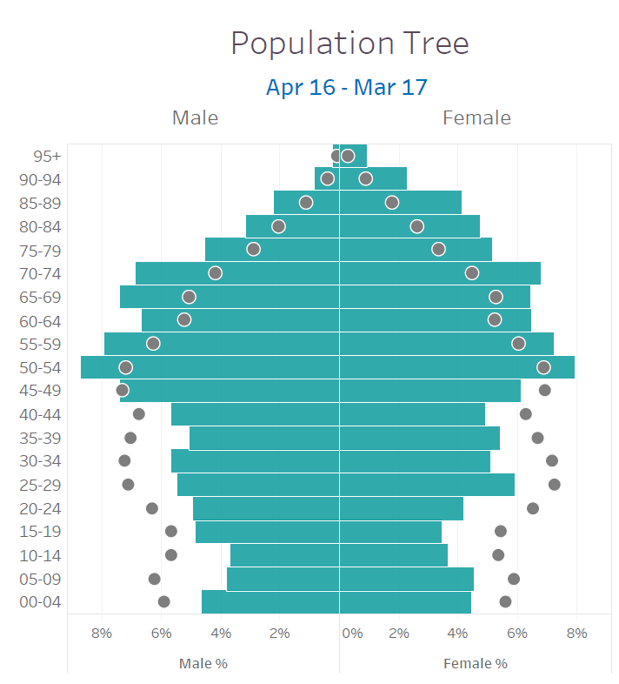
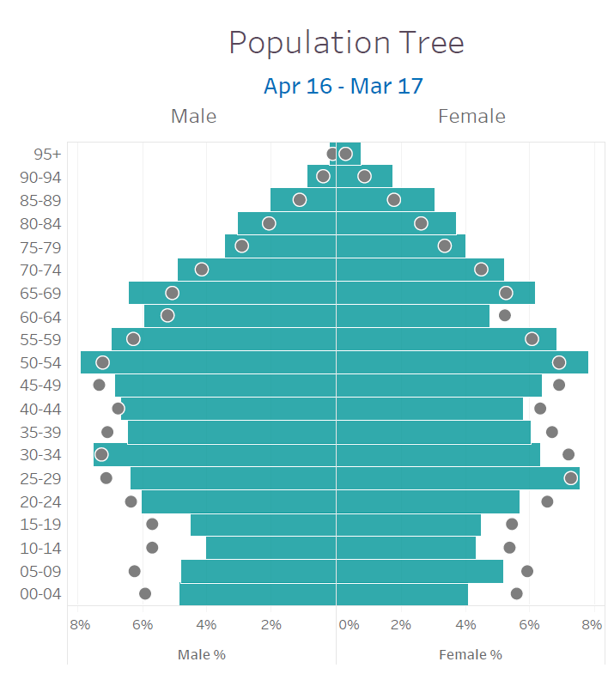

Graham Road Surgery Clarence Park Surgery



Population measure % | Graham Road | Clarence Park | Local Avg | National Avg
Children under 18 | 16 | 15 | 16 | 16
Full-time education/ working age | 49 | 47 | 66 | 62
Unemployed | 9 | 5.5 | 3 | 5
Living with long-term condition | 67 | 75 | 53 | 54
Over 65 years of age | 23 | 25 | 21 | 17.3
Ethnicity %
White/ White British | 93 | 96 | 82
Mixed race | 1.3 | 1.1
Asian / Asian British | 2.3 | 1.7 | 4
Black/ Black British | 0.7 | 0.6
Other | 0.3 | 0.4

A more particular differential is that of deprivation where, according to information from Public Health England, the practice population at Clarence Park Surgery is the fourth most deprived decile in England, where the population for Graham Road Surgery is the second decile (the lowest number indicating the higher deprivation).

Neither option 3 or 4 will significantly adversely impact a specific patient cohort – indeed, the clinical benefits of increased appointment access and availability, a more sustainable and consistent provision of skilled resource, and more fit-for-purpose premises will enhance continuity of care and the associated patient outcomes.

Disease Prevalence
Please see the diagrams below from 2017, outlining the disease prevalence for each practice. The glossary of abbreviations can be found at Appendix 1)
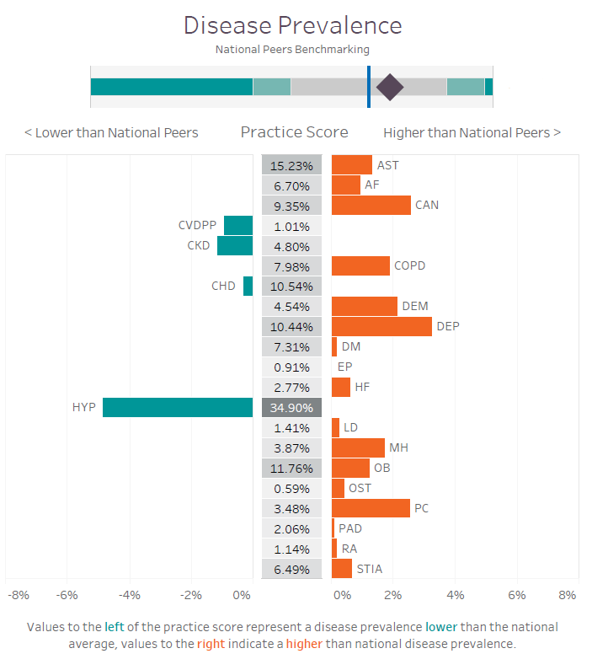
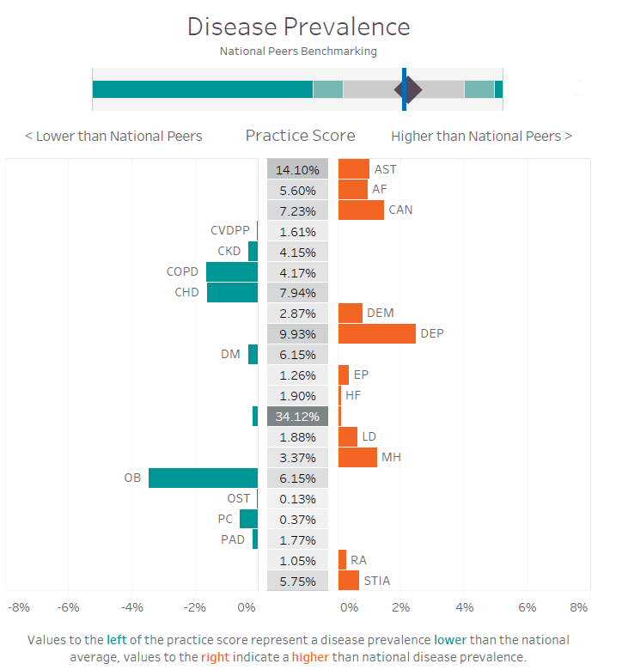
Graham Road Surgery Clarence Park Surgery

Clarence Park Surgery are more than 2% above national peers for the following conditions:
- Cancer
- COPD
- Dementia
- Depression
- Mental Health
- Palliative Care

Graham Road Surgery are more than 2% above national peers for the following conditions:
- Depression

Options 3 and 4 enable far better utilisation of clinical resource and an associated improvement to patient service delivery. Clinical absence can be better covered and the more stable practice position will support recruitment of permanent clinical staff to offer more continuity of care and volume of appointments. Clinical rooms will be consistently equipped to meet the nursing and general practice needs of the type of appointments being offered

Practice Services
There are a range of services offered by Graham Road Surgery and Option 3 would enable these to be extended to Clarence Park Surgery, benefiting patients accordingly.

Use of Other Services
Given the commonality of patient cohorts across the two practices, and the iterative data available, we do not believe that either Option 3 or 4 will adversely impact on the services offered by other services, namely Accident & Emergency, Mental Health, Community Health and Secondary Care.

Transport Services

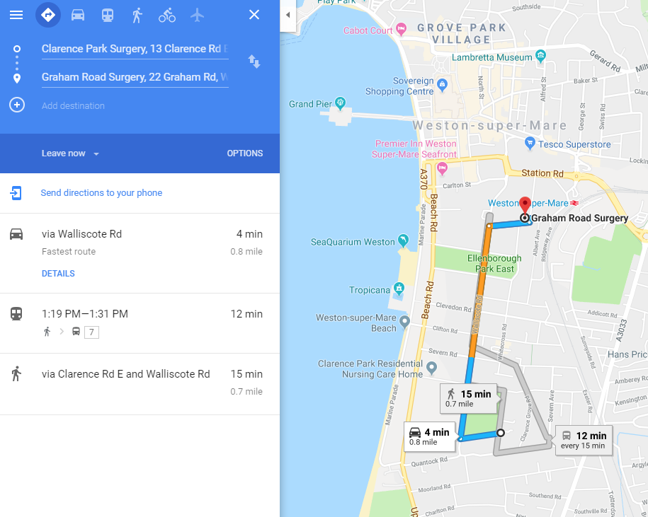

Travel to/ from Clarence Park Surgery to Graham Road Surgery is relatively straightforward.
It equates to a 4 minute bus ride (Service #7), a 15 minute walk on the flat, or a 4 minute cycle ride.

A practice survey at Clarence Park in 2017 found that 85% of patients said they were driven or drive to their appointments. Should Clarence Park offer a nurse-led service then patients attending will have the same residential parking options as currently available. Residential parking is also available at Graham Road but this is more restricted regarding availability and time limitations.

Service Provision
The patient demographics of both Graham Road Surgery and Clarence Park Surgery are best served via sustainable primary care provision, to include consistent and reliable clinical input and fit for purpose premises. The Options appraisal has identified critical financial shortfall in the ability to maintain full primary care services at Clarence Park Surgery. Patients there are already feeling the effect of this given the large number of locum doctors having to be used.

The attached Equality Impact Assessment indicates Options 3 and 4 may result in impact to parents with young children, older people who are frail and/ or have mobility issues and those patients who might need to travel further. However, the improved access and availability of appointments goes someway to mitigate this.

Consideration has been given to access by public transport and for parking. Findings from Healthwatch and Patient and Public consultation will be taken into consideration. It is important to note the associated, proportional gains to these patient cohorts achieved from the improved appointment and service access and availability.

Options 3 and 4 enable improvement to the service provision for Clarence Park Surgery patients, for reasons given above. The more stable and scalable proposal/s will sustain these services and indeed provide a platform for their ongoing improvement and development. These proposals are proportionate to the inconvenience of some patients who will be visiting the other site/s.

Business
Financial position
The NHS England 5 year Forward View (5YFV) recommends that a core part of primary care strategy is to deliver required improvements via providing primary care at scale. The NHS England website summarises this element of the paper:

“There are also efficiencies to be achieved by operating at scale and this is supported by the wider context of 5YFV and working at scale, that then naturally lead onto the subsequent stages and phases of working at scale … General Practice is currently under extreme pressure, with an ageing population and declining workforce, the answer to meeting these challenges lie in working smarter and not necessarily harder. With greater resources there can be strength in numbers.”

This position is sadly familiar to a number of practices across BNSSG CCG geographical area and the move to integrated System working with colleagues across community and secondary care is vital to securing a sustainable future for primary care.

Clarence Park Surgery has a PMS contract which is overseen by BNSSG CCG. General Practice income is primarily driven by an associated contract payment per registered patient, with the application of a ‘weighting’ to allow for variance in practice population demographics (such as deprivation levels, age of patients, disease prevalence etc.). Whilst practices receive additional income from national and local service provision they also have small business expenses for premises, governance requirements, staff and clinical consumables.

Like many practices across the country, Clarence Park is unable to recruit for the number of GP’s needed to sustain their practice population, and are therefore reliant on expensive GP Locums for more than 50% of their GP resource. The current and forecast income projections for the practice are not able to meet the overall practice expenses hence the need for a new service delivery model (Options 3 and 4). Please see the attached financial paper for more detail.

Should Option 3 or 4 not happen then Clarence Park Surgery will hand back the contract as it will be unable to continue without adequate funding, workforce and premises; as per the findings of the Options appraisal for Options 1 and 2.

Estates position
In addition to the financial pressures the practice faces, a recent survey of Primary Care buildings in Weston and Worle reported on 16/10/2018 that the Clarence Park Surgery building is not is not fit-for-purpose.

The building is a 2 storey old, converted, semi-detached house with narrow corridors and limited access via the ground floor only. Whilst there is limited parking on the forecourt this is used for staff only. Patients utilise surrounding residential parking as available. LHC CIC have considered the improvements that would be needed to enable the building to meet patient and business need, and to be scalable for growth. This has been deemed not viable due to the prohibitive cost and disruption this would cause.

Graham Road Surgery is a converted Victorian house over 2 floors, but has the benefit of a lift to the first floor and better disabled access. LHC CIC invested in alterations to improve staff and patient facilities to enable growth and improved access. Whilst there is no on-site parking for patients, clinical staff are catered for. It is recognised that there is limited on street parking surrounding this site.

It is therefore understood that there are no untoward or negative financial implications anticipated with Options 3 and 4; to the contrary, the local health economy will achieve savings against rent and rates currently paid at Clarence Park Surgery under option 4

It should be noted that this is set in the context of a review of primary care estate for Central Weston which may lead to the provision of new premises for the local population. If this were to happen then the Graham Road/Clarence Park service would seek to be a provider in a new location which would be purpose built offering better access, parking and up to date facilities. The reorganisation of service delivery at the two current sites would then be seen as a developmental stage in future primary care provision for central Weston-super-Mare.

Staffing position
The benefits of consolidating clinical resource are:
- Improving work-load management as ‘types’ of clinical intervention will be consolidated
- Increased clinical time as there is no/ less need to travel between sites
- Improved processes and expertise from back office support
- Improved staff retention and ability to recruit due to varied roles and a more stable future
- More effective use of skills and resource enabling delivery of a sustainable, high quality service
- Ability to more effectively train staff in new innovation and service delivery improvements
- Consistent and retained management control
- Absorbing any staff reductions through natural wastage

Governance
‘Planning , assuring and delivering service change for patients’, NHS England, Operations and Information [guidance document 01 March 2018]
Assurance of Service Change: tests of service change

Strong public and patient engagement:
It is vital to ensure the views and experiences of patients, service users, families and cares, and the wider public are heard and that they continue to influence the design/ implementation of service improvements throughout the delivery of the CCG work programme associated with the vision document ‘Healthy Weston: joining up services for better care in the Weston area’.

Healthy Weston is concerned with the whole system of health care across Weston, Worle and the surrounding Villages. Primary Care services within the area are part of this wider system.

This proposal is therefore positioned as part of the wider vision for Healthy Weston, and in the context of the ongoing narrative and commissioning context (Primary Care at scale).

The Patient Participation Group for Clarence Park and Graham Road have already come together to form a single group. There has been initial consultation with the groups about the proposals and the intention is to fully use the group as a reference group in the wider public consultation, which will take place with patients and other stake holders. The main concerns raised by the PPG to date have been regarding the planning and management of appointment capacity and limited on street parking at the Graham Road site.

See the attached Patient & Public Involvement and Communications Plan [Mary Adams v3.0 draft 220119]

Consistency with current and prospective need for patient choice
Clear, clinical evidence base
See Clinical and Patient Position sections

Support for proposals from clinical commissioners:
For the local health economy within Weston-super-Mare it will prevent a potential practice closure and subsequent list dispersal. Please also reference the CCG vision document: Healthy Weston: joining up services for better care in the Weston area. Healthy Weston is concerned with the whole system of health care across Weston, Worle and the surrounding Villages. Primary Care services within the area are part of this wider system.

Sufficient alternative provision, such as increased GP or community services is being put in place
See Business position section

Risks
- Both practice financial positions further threatened by ongoing contract reductions, list churn, increase in costs, funding cuts, increase in patient demand etc.
- If the lists are not merged this will severely limit the ability of the resources to be effectively deployed, leading to a likely closure of a service
- An un-managed Clarence Park closure would be distressing for patients and put strain on neighbouring practices
- The increase to demand at Graham Road may impact on patient service delivery

Issues
- Practice patients escalate concerns (about the future), creating unwanted focus and publicity
- Staff (clinical or non-clinical) leave the practice/s, increasing vulnerability and costs

Roles & Responsibilities
Name | Role | Responsibility
Mark Graham | Chief Executive  For All Healthy Living Company &  Locality Health Centre CIC Group | Business proposal  Staff liaison
Fraser Black | Finance Director  For All Healthy Living Company &  Locality Health Centre CIC Group | Financial proposal  Business modelling
Dr Nick Cooper  Ruth Rice | Lead GP and Lead Advanced Practice Nurse (affected by the proposed changes) | Clinical modelling and governance  Support development of proposal  Proposal advocate  Support engagement and implementation of proposal  Communicate proposal/ benefits to wider community
Chris Perks | Practice Manager (affected by the proposed changes) | Support development of proposal  Support engagement and implementation of proposal
Mary Adams | Partnership & Engagement Manager  North Somerset Area team  BNSSG CCG | Patient & Public Involvement  Equality Impact Assessment  Local Authority (HOSP) liaison
Colin Bradbury | Area Director  North Somerset locality  BNSSG CCG | Ensuring commissioning intentions reflect the local commissioning plans
David Moss | Head of Primary Care Contracts  BNSSG CCG | Ensuring contract intentions reflect the local commissioning plans
Mel Green | Head of Locality Development  BNSSG CCG | Commissioning lead for service change
 | Practice Patient Group | Independent group which reflects the concerns, perspective and advice of the practice patients.
Linda Buczek | Senior Delivery Manager  One Care (BNSSG) Ltd | GP Federation support  Facilitation of evidence base

Decision Making Pathway/ Milestones – correct as at document version date
Date | Activity | Who | Status
July | Locality Health Centre contract: decision not bid | Mark Graham (MG) | Complete
August | Practice financial forecast: Clarence Park not sustainable stand-alone | MG  Fraser Black (FB) | Complete
September | Practice communication: options of potential sale and closure | MG | Complete
October | Failed procurement of Locality Health Centre | MG | Complete
November | Public meeting | MG/ FB/ staff  Colin Bradbury  Councillors  Patients | Complete
w/c 10 Dec | Development of PPI and Communications plan  Arranging dates/ venues for public meetings  Completing Equality Impact Assessment  Website copy published  Drafting Case for Change | Mary Adams (MA)  MA  NB  MG  Linda Buczek (LB) | Complete
w/c 17 Dec | Attending PPG Chairs meeting to update | MG | Complete
w/c 24 Dec | Holiday week | All | Complete
w/c 31 Dec | Drafting Case for Change  Preparation of communication materials  Staff engagement planning | MG / LB  MA  MG | Complete
w/c 07 Jan | Targeted outreach work planning  Survey development  Preparation of communication materials  Patient sub-group meeting | MG/MA  MG/MA/ Comms  MA  MG  Dr N Cooper (NC) | Complete
w/c 14 Jan | Project: not proportional to write to all patients  Preparation of paper for HOSP  Planning outreach meetings  Online survey  PPI & Communications Plan (draft v2) | MG/MA/LB  LB/MG  MA/ MG  MA | Complete
w/c 21 Jan | Preparation of paper for HOSP  Share papers with CCG & Primary care leads  Letters to key stakeholders  Locality board meeting  Case for Change draft | MG/LB  MG/LB  MG  MG/LB | Complete
w/c 28 Jan | Equality Impact Assessment (v0.2 20190130)  Case for Change (final draft)  Consultation papers submitted | Niema Burns (NB)  MG/ LB  MG/LB/MA | In progress
w/c 04 Feb | Engagement starts (5th Feb to 31st Mar)  Public meetings: Clarence Park Baptist Church | All  MG/MA/NC
w/c 11th Feb | Monitor survey results  Respond to requests for community meetings  Collate and analyse feedback from public meeting  Record feedback into a database | MG/MA  MG/MA  LB
w/c 18 Feb | Monitor survey results  Respond to requests for community meetings  Collate and analyse feedback from public meeting  Record feedback into a database  Submit papers to HOSP | MG/MA  MG/MA  LB  MG/LB
w/c 25 Feb | Monitor survey results  Respond to requests for community meetings  Collate and analyse feedback from public meeting  Record feedback into a database  Locality board meeting  Health Overview Scrutiny Panel (HOSP) | MG/MA  MG/MA  LB  MG  MG
w/c 04 Mar | Monitor survey results  Respond to requests for community meetings  Collate and analyse feedback from public meeting  Record feedback into a database | MG/MA  MG/MA  LB
w/c 11 Mar | Monitor survey results  Respond to requests for community meetings  Collate and analyse feedback from public meeting  Record feedback into a database  Healthwatch consultation (tbc) | MG/MA  MG/MA  LB
w/c 18 Mar | Monitor survey results  Respond to requests for community meetings  Collate and analyse feedback from public meeting  Record feedback into a database  Public meeting/s 19th Mar  Purdah commences (20th Mar to 2nd May) | MG/MA  MG/MA  LB  NC/MG/MA
w/c 25 Mar | Engagement closes 31 March  Locality board meeting
w/c 1 April | Analysis of all feedback to support business case and decision making process  Prepare papers for Primary Care Commissioning Committee (PCCC)  PPI feedback report for practice consideration | LB/MG/MA  MA/LB  MA
w/c 15 April | Case for Change submitted to PCCC | MA/LB
w/c 29 April | BNSSG CCG Primary Care Commissioning Committee (30th April 09.00 – 12.00)  Local election purdah ends 2nd May | MG
w/c 13 May | Implementation plan updated:  Setting out how the changes will be taken forward, when and by whom. The plan will identify key milestones against which progress can be monitored | MG

Appendix 1 – Disease Prevalence abbreviations
Abbreviation | Clinical Term
Clinical prevalence | The number of patients with a particular condition expressed as a percentage of the practice list size.
AST | Asthma
AF | Atrial fibrillation
CAN | Cancer
CVDPP | Cardiovascular disease – primary prevention
CKD | Chronic kidney disease
COPD | Chronic obstructive pulmonary disease
CHD | Chronic heart disease
DEM | Dementia
DEP | Depression
DM | Diabetes mellitus
EP | Epilepsy
HF | Heart failure
HYP | Hypertension
LD | Learning disabilities
MH | Mental health
OB | Obesity
OST | Osteoporosis
PC | Palliative care
PAD | Peripheral atrial disease
RA | Rheumatoid arthritis
STIA | Stroke and transient ischaemic attacks

Other Abbreviations used:

BNSSG | Bristol, North Somerset & South Gloucestershire
CCG | Clinical Commissioning Group
PCCC | Primary Care Commissioning Committee
CIC | Community Interest Company
PPG | Patient Participation Group
PPI | Patient and Public Involvement
HOSP | (Local Authority) Health and Overview Scrutiny Panel
ANP | Advanced Nurse Practitioner
PMS | Provider of Medical Services

