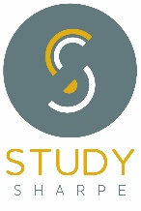
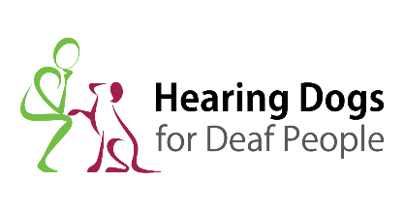
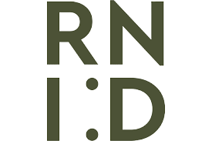
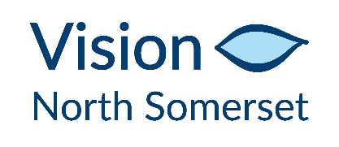
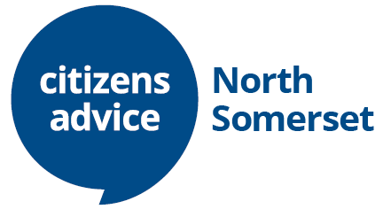

Is North Somerset Deaf Aware?
The North Somerset Deaf Awareness Partnership has conducted a survey to discover the answer. The responses and recommendations are detailed in this report.

Background
The Deaf community is mainly made up of 2 groups of people – those who were born Deaf or lost their hearing during childhood, and those who have lost their hearing as adults. The first group (Deaf with a capital D) are often profoundly deaf and may communicate via British Sign Language (BSL). BSL is a recognised language and has different grammar and word order from English. Many BSL users find it difficult to read long sentences in English, although they do communicate by text and short emails. The second group (deaf with a small d) are referred to as Hard of Hearing and can communicate in English.
Because deafness is not a visible condition, Deaf, deafened and hard of hearing people can feel misunderstood, unseen, invisible and isolated.
Despite some high profile successes recently - Rose Ayling-Ellis winning Strictly Come Dancing, Troy Kotsur winning an Oscar as Best Supporting actor in his role in CODA (Child of Deaf Adults), and British Sign Language given legal recognition – most Deaf and Hard of Hearing people still face problems every day because services are not Deaf Aware.
The situation has got worse during the pandemic because of facemasks. This means that Deaf and Hard of Hearing people aren’t able to lip-read. Also many organisations have closed their offices and ask users to phone instead. Not easy if you’re Deaf!

The Survey
In North Somerset members of the d/Deaf community and organisations working with them come together as the NS Deaf Awareness Partnership to mark Deaf Awareness Week in May each year.

This year the national theme for the week was Inclusion. So we launched a simple survey (see Appendix 1) to ask members of the d/Deaf Community 2 questions:-
Which services are deaf aware and make you feel included?
Which services are NOT deaf aware and make it difficult for you to use them?

The Method
We publicised the survey in the Weston Mercury and NS Times, also on the NSC website and their internal newsletter The Knowledge. We also sent a copy of the survey to 30 members of the Hard of Hearing Group, and followed up by individual interviews. For BSL users, we asked 15 people for their comments at the monthly Communication Café. The survey was conducted during May and June 2022.

Summary of responses
Although this was a small survey and limited geographically, the results were interesting and show where improvements could be made by adopting best practice, especially in health settings. We did receive one survey on behalf of an 8 year old child with hearing loss, which we are following up separately.
The individual responses, both positive and negative, are set out in Appendices 2 and 3. For GP surgeries, we give the name of the surgery for positive responses, but list negative responses under the name of the relevant Health Group (MV for Mendip Vale or PH for Pier Health), because of the small size of the survey.

Call Centres - Our respondents told us that call centres are very difficult to use if the advisers have unfamiliar accents or speak too quickly. Profoundly deaf people have to ask someone to phone on their behalf, which takes away their independence. Many more services are now only accessible by phone as local offices have closed.
Use of screens and masks - During the pandemic, organisations put up screens and staff wore masks, but some organisations have not relaxed these requirements. This makes it very difficult for the d/Deaf community.
Health settings - Contrary to our expectations that GP surgeries and the Audiology Department at Weston General Hospital (WGH) would be Deaf Aware, we found this not to be the case for many of those who responded to our survey.
As regards GP surgeries, there was a wide variety of opinions – some surgeries had embraced new technology e.g. texting, and were aware of the requirement to book a BSL interpreter. Some were simply not Deaf Aware. Sometimes this was down to whether individual staff members were prepared to be flexible.
As regards Audiology, one case sums up the situation. A profoundly Deaf couple in their eighties were waiting in the waiting room for hours. They can hear only a little with the help of hearing aids, both of which needed replacing, hence their appointments. Eventually they knocked on a door to complain and were told that their names had been called. It transpired that an audiologist had stood somewhere behind them and called out their names. A family member subsequently complained and was told that the clinicians are supposed to collect their patients from the waiting area, not just call their names. But this is clearly not always happening.

Recommendations
1) All call centres should follow the procedure recently introduced by North Somerset Council where the advisers have a card, reminding them to speak slowly and clearly, which they put up if a caller tells them they are hard of hearing.
2) All organisations should provide some Deaf Awareness training for staff, especially those who are customer-facing. They could start with our Top Tips https://www.northsomersetlife.co.uk/news/raising-awareness-deafness or organise face-to-face or online training.
3) If pandemic restrictions (screens, masks and social distancing) are maintained or re-introduced in GP surgeries, allowances should be made for the d/Deaf community - for example use of a clear mask or visor to facilitate lip-reading, or sitting back and dropping the mask.
4) GP surgeries should record on their systems that a patient is Hard of Hearing or uses BSL and then communicate with them in an appropriate way. For example, wider use of text messaging, text relay, sign video and transcription Apps.
5) The Audiology Department at WGH should review their seating arrangements and ensure that all staff follow the procedure for collecting patients. They should reintroduce the drop-in to avoid patients having to phone up for an appointment.
6) Weston General Hospital should offer an audiology service for children as well as adults. This would avoid children having to travel to Bristol.
7) In meeting rooms, acoustics of walls, floors and ceilings should be considered so that ambient sound is absorbed. This would make it easier for hard of hearing people to hear the speaker above the clatter.

For more information, please contact Bridie Collier bridie.collier@nscab.org.uk or
Liz Watkins liz.watkins@n-somerset.gov.uk

On behalf of the North Somerset Deaf Awareness Partnership:-
Angela Avery, Derek Boardman, Jen Booker
Bridie Collier, EDI Campaigner, Citizens Advice North Somerset
Dana Jackson, NSC Inclusion Officer
Dave Raby, Hearing Equipment Officer, Vision North Somerset
Emm Sharpe of Study Sharpe, Deaf Awareness trainer
Gill Drennan, lip-reading tutor
Liz Watkins, Social Worker with Deaf people, NSC
Lucybeth Brewer, Hearing Dogs Volunteer
Maggie Kirkup, RNID Volunteer
Victoria Bailey, Police Link Officer for Deaf people

September 2022
Appendix 1
Deaf Awareness Week 2-8 May 2022

SURVEY FOR INCLUSION

Which services are deaf aware and make you feel included? Which services are NOT deaf aware and make it difficult for you to use them?

Think about shops, cafes, restaurants, banks, energy companies, broadband and phone companies, taxis, trains, buses, GP surgery, hospital, opticians, dentists, and any others good or bad. Explain why they are good or bad.

Type of service | GOOD | BAD

Please put your completed form in the letter box outside Citizens Advice NS, 39 Oxford Street, WSM or email it to bridie.collier@nscab.org.uk

Appendix 2
Positive Experiences

- GWR has designed a card which people can pick up at train stations explaining that they are Hard of Hearing.
- Trains/buses now have much more visual information
- Hotels, cafes, restaurants – usually helpful once they realise you are hard of hearing
- Coffee#1 – most staff deaf aware
- NSC’s “Do it online” facility avoids having to phone up to report a problem
- St Mary’s Church in Yatton has a very good loop system
- Receptionist at Houstons Dentists will drop mask if asked
- Dentist – receptionist is deaf aware and speaks clearly
- Optician – generally good once aware I am deaf
- Chemist staff very helpful and will write things down if asked
- At Tudor Lodge the receptionists and announcers speak loudly so patients can hear
- 168 Medical are happy to book an interpreter for BSL patient
- 168 Medical allow a BSL user to send a text message
- 168 Medical supports AskmyGP which avoids having to phone up
- St Georges Dr typed out Questions & Answers
- Yatton surgery – staff remove masks if asked and e-consult works well
- At Langford Surgery, a member of staff without being prompted opened a transcription App for me so their words appeared on a phone
- One GP removed their mask when asked and wrote everything down.
- Audiology @ Weston texted one user to confirm his appointment
- Audiology @ Weston – staff member fetched visor in place of mask
- Weston General Hospital – most staff are deaf aware especially in ENT and Audiology departments

Appendix 3
Negative Experiences
- BT, Sky, call centre staff don’t speak up and have non-local accents
- Call centres, energy companies - background music and unfamiliar accents make communication difficult, have to get someone else to phone for me
- When phoning a bank they need constant reminding to speak slowly and clearly
- Some banks still have screens up – very difficult to hear through
- Opticians – assistants do not speak clearly enough
- Some taxis/bus drivers are not deaf aware and do not speak clearly
- On train, announcements are inaudible
- Local cinemas rarely have subtitled screenings
- As a National Trust volunteer, I have to keep reminding staff to speak slower, despite the NT professing to be disability aware
- There is only one hearing support teacher for the whole of Bristol, North Somerset and South Glos so children with hearing loss cannot get enough help
- New schools need to take the acoustics into account
- Audiology drop-in cancelled, have to phone up for an appointment
- Audiology, Pharmacist, Hairdresser - can’t hear because of accent and masks
- Audiology @ Weston do not provide interpreters for BSL users
- Audiology @ Weston Waiting area is far from deaf-friendly. Seats face away from the department, call in is by voice, the TV sound is on (but no subtitles). The staff stand behind patients and call out their name, rather than facing them to allow lip reading
- Weston General Hospital usually need reminding to speak clearly
- Receptionists at some surgeries will not drop their mask, even when asked
- At one MV GP surgery, have to keep reminding GPs to speak more slowly
- At one MV GP surgery, patients called in by voice but caller stands behind the seats
- One MV GP surgery sent a link to an App for recovery exercises after an injury but it was not subtitled so the patient couldn’t follow it.
- One PH GP surgery phones patient back in response to a text message
- At one PH GP surgery – masks cause problem as can’t lipread, also different doctors
- At one PH GP surgery – different doctors changing all the time
- One PH GP surgery – no deaf awareness
- One PH GP surgery – Bad attitude – do not understand patient needs

